**Project Summary Aptech/North Nazimabad**

E-Project Review Document

|  |  |  |
| --- | --- | --- |
| **Report Date** | **Project** | **Start End Date Of Project** |
| **21-Nov-2019** | **Wilson Sporting Goods** | **04-Nov-2019 – 04-Dec-2019** |

Problem Statement:

WILSON SPORTING GOODS is selling various types of Sports Goods. The company advertises by distributing the pamphlets, advertising on television and so on. Due to rapid development in internet field, the company decides to launch a website where people will get all the information about the various products available with them easily.

Project Progress:

Pages

**Home Page**

**Contact Us**

**Location**

**Online Shop**

**Categories**

HOME PAGE:

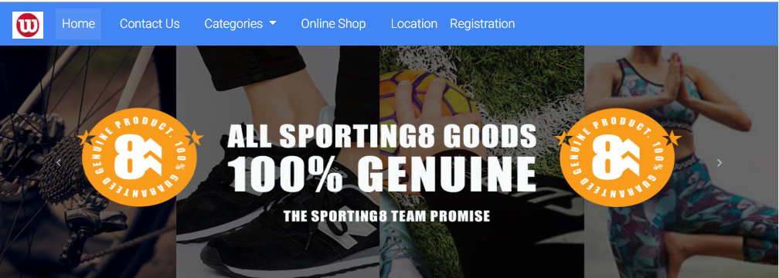

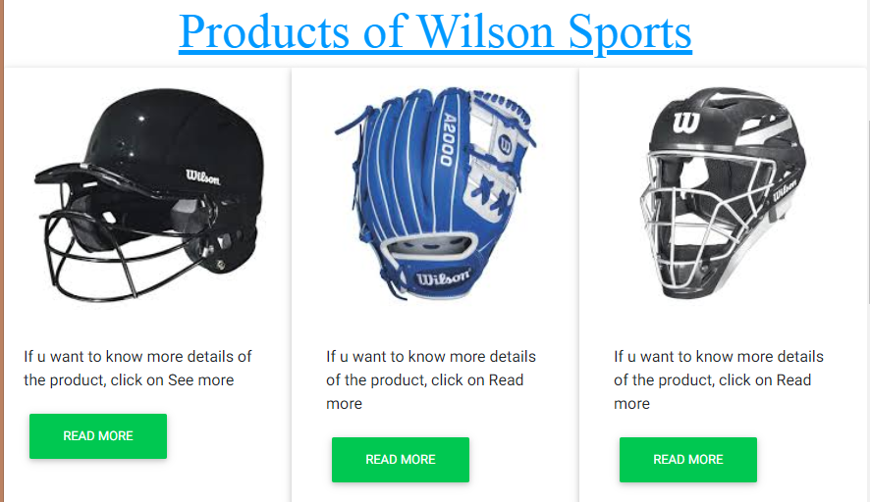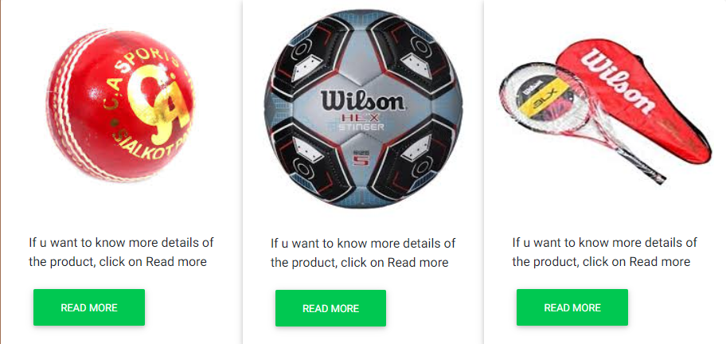

**READMORE & READLESS FUNCTION:**

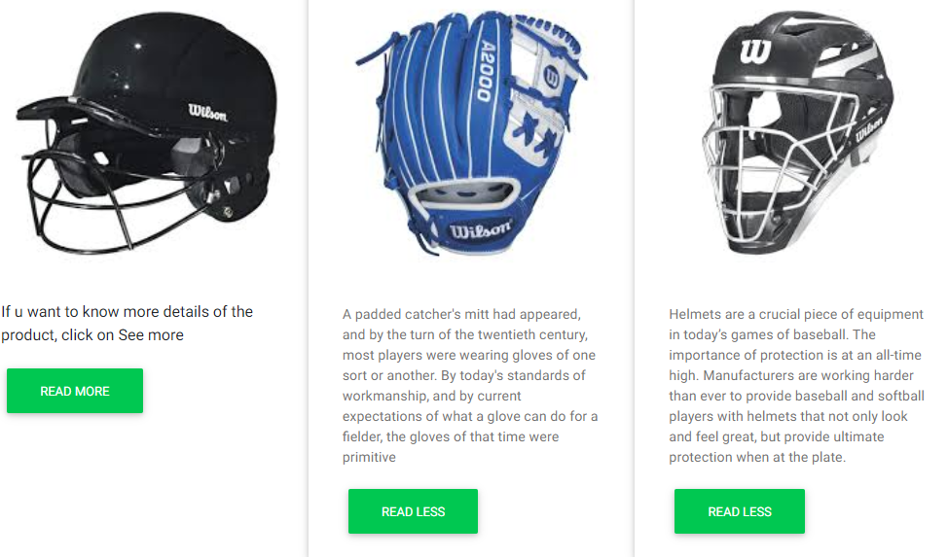

ONLINE SHOP

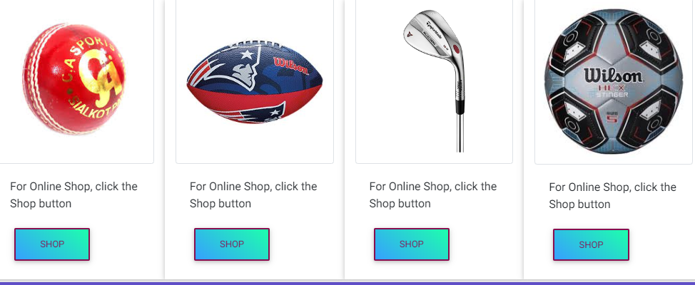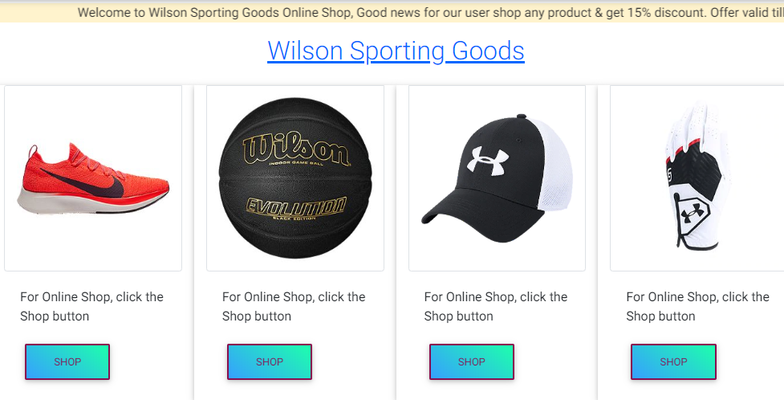

**GLOVES SHOP:**

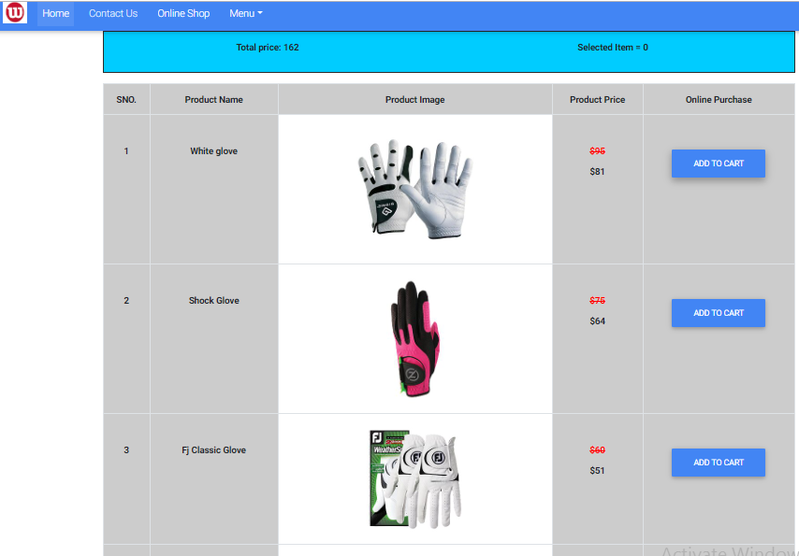

**CATEGORIES SECTION:**

**MEN’S CATEGORIES:**

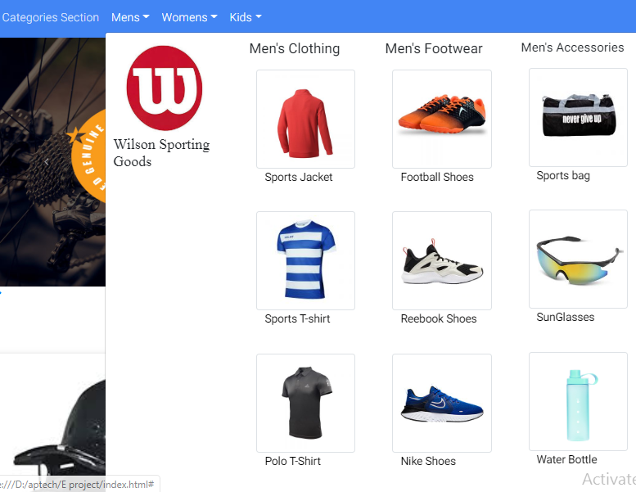

**SPORTS JACKET SHOP**

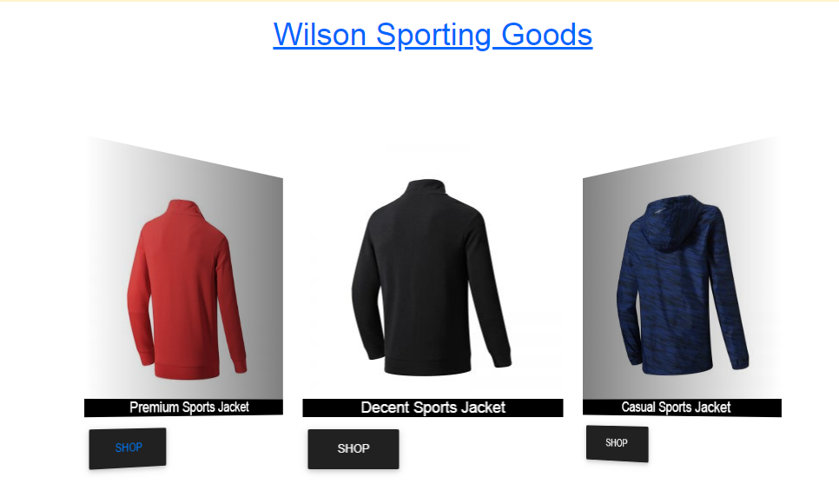

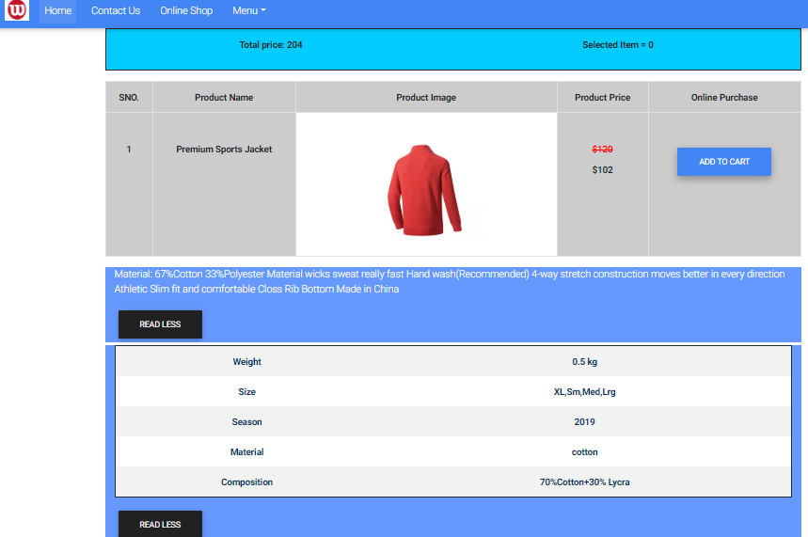

**CONCTACT US:**

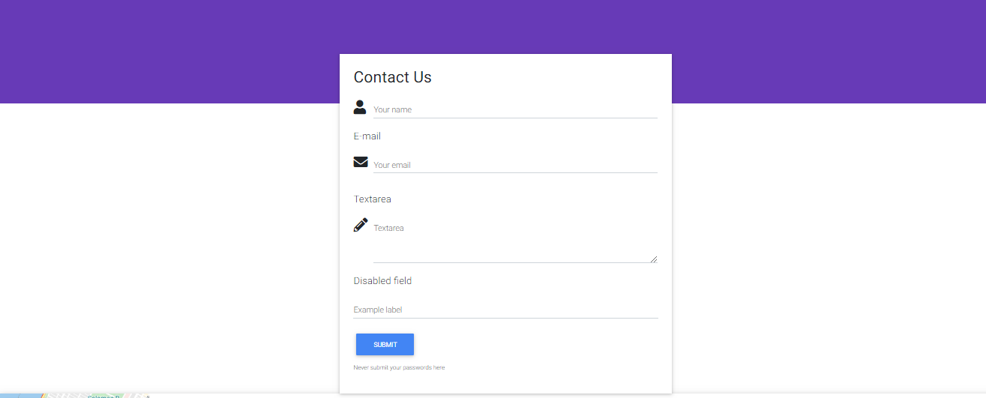

LOCATION:

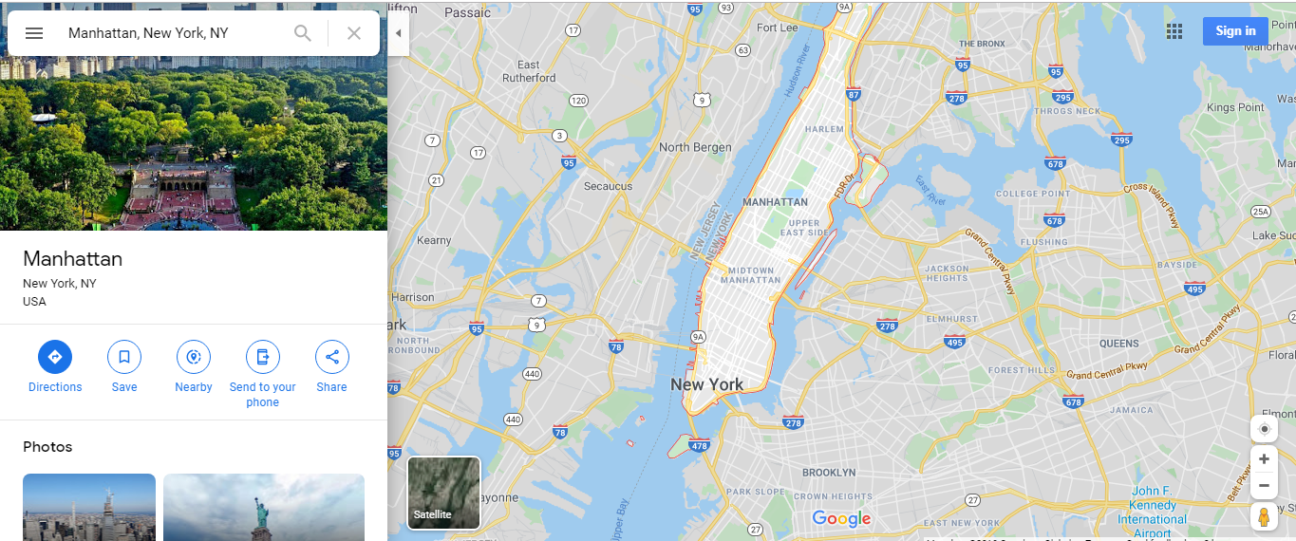

ADIDAS PRODUCT SHOP:

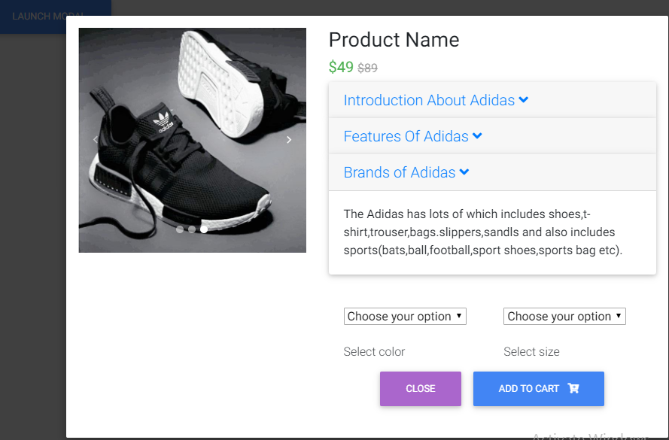

GROUP MEMBER & WORKING

|  |  |  |
| --- | --- | --- |
| STUDENT NAME | ENROLLMENT # | WORKING |
| **Wajahat Mansoori** | **Student1214179** | Home page, Carousel, Products Intro with Readmore & Readless Function, Footer, Online shop Page, List of Different Products, & by clicking on any products the sub list of that product will open. For Example If user Click on Sports Shoes then all the products related to Sports shoes will show to the user, Add to Cart Function in which the price of the product will add in above table section of the Web page. Create 3d sports jacket shop using Swiper. |
| **Yaseen Saleem** | **Student1214181** | Design a page in which logo of different sports company are available & user can shop products according to their choice of the brands. For example if the user want to shop Adidas product they can easily shop Adidas Product by clicking on the Adidas logo, user can also select the colors & size of the products. |
| **Anas Ansari** | **Student1214182** | Design Contact Us Form & Add location of the Company. |
| **Ubaika** | **Student1214173** | Design category Mega Nav Bar in which different categories of sports Products W.R.T genders are available. For Example, if user want to search Men’s product he can easily access by clicking the products mentioned in the list. Create sports jacket cart page, in which the description of the product as well as addition information of the product mention also user can buy the product if he want to buy. |